Validation testing.

No mistakes:

1. Select all options:

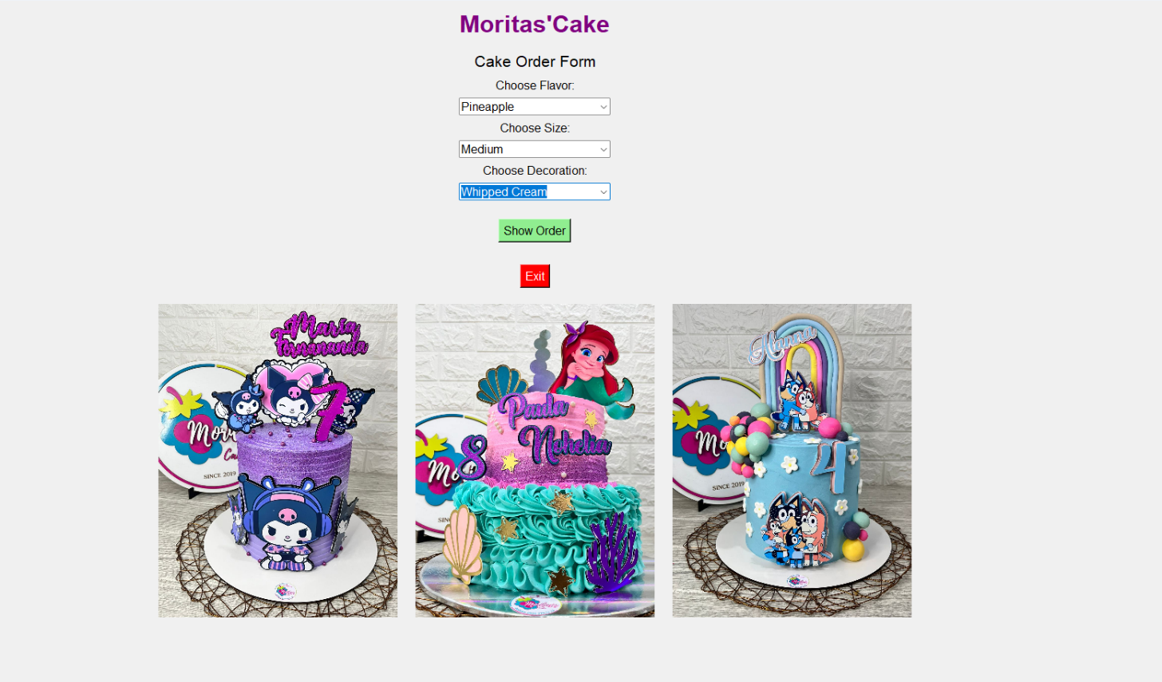

1. Select the “show order” option to see your order

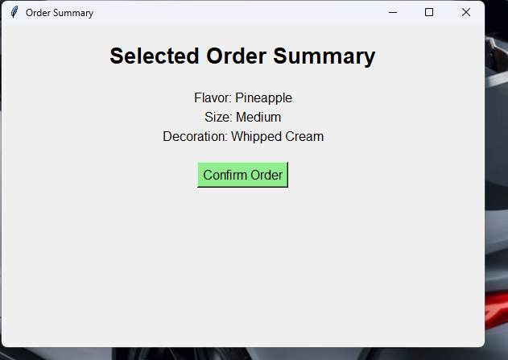

1. After pressing the button, you will see your cake purchase completed.

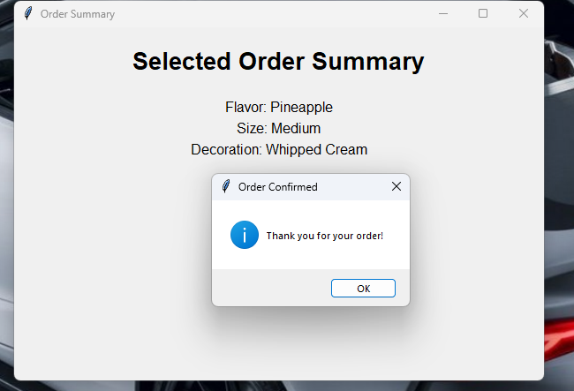

Forgetting to choose an option:

1. If you forget to choose one of the three options, you will be shown a warning message.

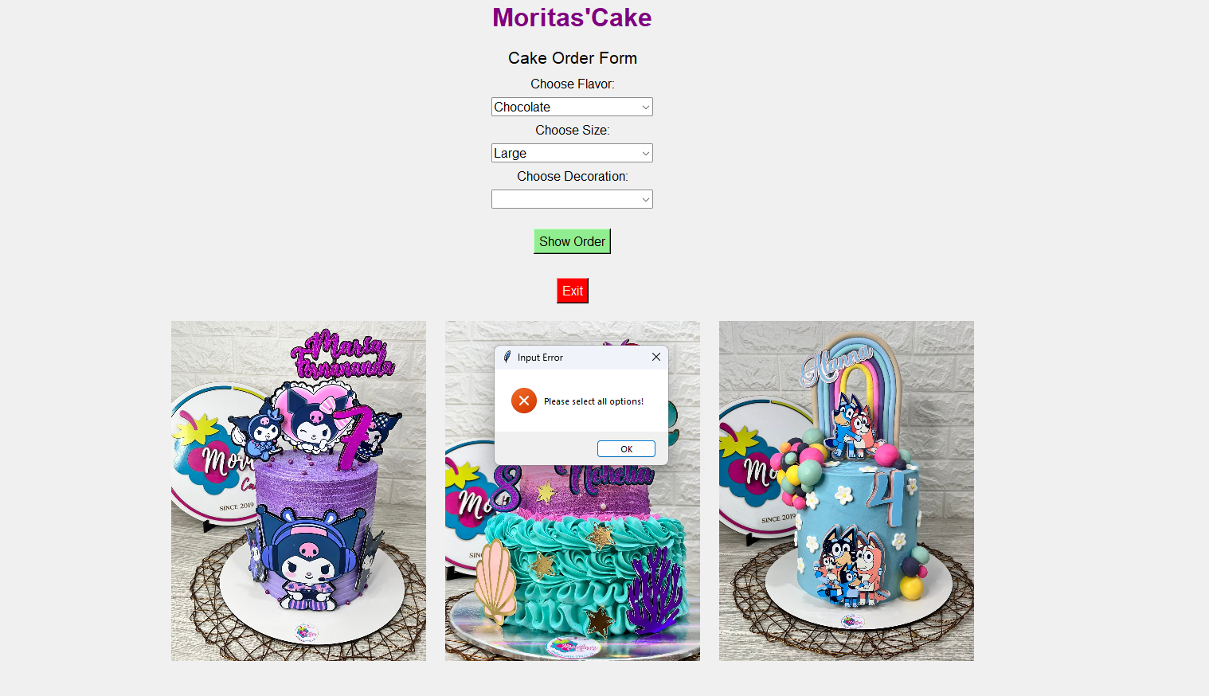

1. You will correct the error and you will be able to make your purchase successfully.

